**Name:** Etcherla Sai Manoj **Mis. No:** 112015044 **Branch:** CSE

**Code:**

#include<iostream>

using namespace std;

struct student

{

char name[50];

float marks;

};

int main(){

int n;

cout << "\nEnter number of students : ";

cin >> n;

student s[n];

int sum = 0, max_score = 0;

cout << "\nEnter name of the student and his respective marks\n\n";

for(int i = 0; i < n; i++){

cout << "Enter name of Student " << i+1 << " : ";

cin >> s[i].name;

cout << "Enter marks of Student " << i+1 << " : ";

cin >> s[i].marks;

//calculates sum of marks

sum += s[i].marks;

//calculates highest examination score

if(max_score <= s[i].marks){

max_score = s[i].marks;

}

}

//calculate average of examination marks

float average = sum / (float) n;

cout << "\n---------------------------------------------------------\n";

cout << "\nThe average of examination marks is : " << average << "\n";

//prints names of students who scored below average examination mark

cout << "\n---------------------------------------------------------\n";

cout << "\nStudents who got marks below average" << "\n";

for(int i = 0; i < n; i++){

if(s[i].marks < average){

cout << s[i].name << "\t" << s[i].marks << "\n";

}

}

//prints highest examination score

cout << "\n---------------------------------------------------------\n";

cout << "\nThe highest examination score is : " << max_score << "\n";

//prints names of students whose examination score is same as highest examination score

cout << "\n---------------------------------------------------------\n";

cout << "\nStudents who scored highest marks in the examination" << "\n";

for(int i = 0; i < n; i++){

if(s[i].marks == max_score){

cout << s[i].name << "\t" << s[i].marks << "\n";

}

}

cout << "\n---------------------------------------------------------\n";

return 0;

}

**Code:**

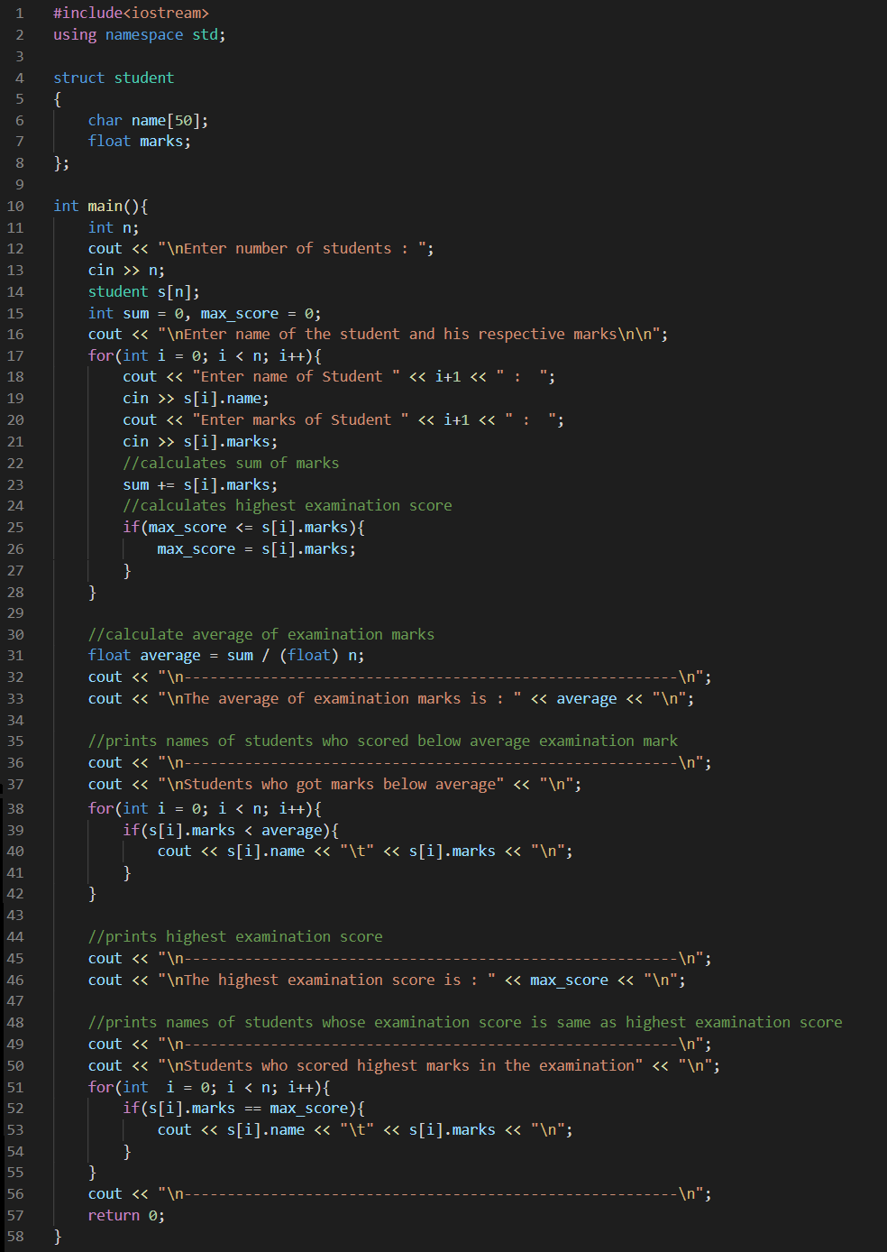

**Input & Output:**

